**Getting Started**

****

**Landscape Teaching Unit 0.2**

**Introduction to Big Geography**

**Table of Contents**

|  |  |
| --- | --- |
| Why this unit? | 2 |
| Unit objectives | 2 |
| Time and materials | 2 |
| Authors | 3 |
| The historical context | 3 |
| Lesson 1: Seeing the world  tT | 4 |
| Lesson 2: How many continents are there? | 14 |
| Lesson 3: The personality of Earth’s surface | 22 |
| This unit and the Three Essential Questions | 36 |
| This unit and the Standards in Historical Thinking | 36 |
| Resources | 37 |
| Conceptual Links to Other Teaching Units | 38 |

**Why this unit?**

Before launching into any course on world history, students need to explore the terrain on which human history took place. Students are exposed to exciting concepts about the earth’s formation and dynamic processes in science classes, but they seldom have the opportunity to link this information to history. Geography studies, on the other hand, often focus on the state of the contemporary world. This teaching unit introduces the concept of Big Geography, an innovative way of looking at the divisions and connections of the world as a dynamic stage for human activity over thousands of years. This unit challenges many conventional or traditional notions about geography in order to prepare students and teachers to look at larger scales of time and space. In the three lessons in this unit, students will review much of what they know, fulfilling numerous objectives from the National Geography Standards in the process of developing historical thinking skills as they relate to geography. A prominent learning objective in this unit addresses the concept of “region” in geography. Students will consider how people have conceived of and created regional divisions and how the definitions of region have changed over time in response to new evidence and new ways of viewing human and biological space.

**Unit objectives**

Upon completing this unit, students will be able to:

1. Differentiate among various flat world map projections in terms of their relative distortion of land shape and area.
2. Identify the earth’s continents and describe alternative ways of naming them.
3. Evaluate geographers’ opinions concerning the boundaries of continents and their relationships to each other and to bodies of water.
4. Compare views of earth from different vantage points and identify several large regions as stages of world history
5. Define continental drift and explain in general terms how global land masses came to be distributed as they are today.
6. Analyze the relationship between vegetation zones, population distribution, and paths of interaction in historical time.
7. Evaluate topographical features of earth in terms of their impact on the mobility of flora, fauna, and human beings.

**Time and materials**

These three lessons take three to five class periods to complete, though teachers may choose to introduce one or two of the lessons.

Materials

* Student handouts
* Globes and atlases
* Thin tracing paper or markable transparency film
* .05 cm graph paper
* Calculators
* Wall map (physical earth) (optional)
* Computer with Internet access (optional)

**Author**

Dr. Susan Douglass is the Education Outreach Coordinator in the Center for Contemporary Arab Studies at Georgetown University. She received her Ph.D. in World History at George Mason University and has an M.A. in Arab Studies from Georgetown and a B.A. in History from the University of Rochester. Her major publications include *World Eras: Rise and Spread of Islam, 622-1500*, the children’s book *Ramadan*, and the national study "Teaching About Religion in National and State Social Studies Standards," Freedom Forum First Amendment Center and Council on Islamic Education. Susan is a founding member of the World History for Us All team.

**The historical context**

This unit introduces world history from the beginning of geologic time, and it encompasses the whole of human history. Its lessons deal with the natural and human divisions of the globe and with people’s changing perceptions of those divisions based on scientific and historical evidence. The unit builds upon students’ prior knowledge of earth and life science and challenges them to link that knowledge to an overall view of human history. It presents a conceptual geographic framework for considering the earliest human settlements and migrations, as well as current population distribution and communication across the globe. It also presents geographic, historical, and scientific evidence challenging conventional views of the division of land masses into continents. It encourages students to think about how land masses and waterways are interconnected, and how this has affected human, plant, and animal life over time. Finally, as an introductory unit, the lessons provide a needed review of map skills and identification of major geographic features.

***Lesson 1***

***Seeing the World***

**A lesson in three parts**

* Part 1: Calculating distortions on world map projections
* Part 2: Setting the scene of history: continental drift and geologic time
* Part 3: Viewing earth from different vantage points: theaters of human history

**Materials**

* Student Handouts 0.1.1 - 0.1.3 (optional: copy Student Handout 0.1.1 on transparency)
* Graph paper (.05 cm spacing on thin paper or transparency)
* Calculators
* Freestanding globe, Google Earth (<http://www.google.com/earth/>)

**Part 1: Calculating distortions on world map projections**

**Procedures**

1. Divide the class into at least three groups. Assign each group to study one of the three different world map projections on Handout 0.1.1 (Mercator, Peters, or Robinson projects). Have them find the relative area of the continents (as conventionally defined) by superimposing 1-cm graph paper on each map. Copy the centimeter grid onto transparency film. If more than one group works on each map projection, they can check and compare each other’s results.
2. Estimate the number of sq cm of water versus land area and use a calculator to compute the approximate percentage on each projection.
3. Using the centimeter grid, have students working in groups estimate the number of square cm of the land masses listed on the table in Handout 0.1.1 and place the figure in the appropriate boxes. Use a calculator to compute the area and percentages of the total global surface area and enter into the appropriate boxes.
4. Using the data on Handout 1.1, determine the total surface area of the globe in sq km. Find out the actual area of each continent in sq km and enter it into the appropriate boxes. Using a calculator, find out the total percentage of earth’s surface covered by each continent’s area. Enter the results in the appropriate box. Use these figures to compare the map projections.
5. Using an overhead projector transparency of the chart in Handout 0.1.1, ask each group for its results after studying the projection. Compare the relative area of each land mass on the various projections. Which land masses are most distorted relative to their actual area? Which are least distorted on the various map projections?

**Discussion**

* 1. How might use of the Mercator projection in schools have affected generations of students in terms of their perception of the relative size and importance of different land masses?
  2. Even assuming that people realize that the sizes of Greenland and Antarctica are out of proportion on the Mercator projection, how are people likely to perceive the relative sizes of Asia and Africa? Are people likely to perceive that a relative size distortion exists? Why or why not?
  3. Equal area projections are quite commonly used now. How might that fact affect the geographical perceptions of the current generation of students and readers of print and electronic media?

**Part 2: Setting the Scene for History: Continental Drift and Geologic Time**

**Procedures**

1. View online animations that illustrate the theory of plate tectonics and show continental drift over millions of years. Have students briefly review or research the theory of continental drift. Students may be asked to summarize their research results in verbal or graphic form. The geology portal at the University of California, Berkeley’s Museum of Paleontology site has animations in varying file sizes. See <http://www.ucmp.berkeley.edu/geology/tectonics.html>. The site also features links to detailed information about geologic periods. See <http://www.ucmp.berkeley.edu/exhibit/geology.html>.
2. For younger students, explore the mechanics of plate tectonics and continental drift at a simpler level by having students play the interactive games *Crusty Stuff* and *Plate Action* in the “What on Earth” science section at WickED, the educational web site of the New Zealand schools. See <http://www.tki.org.nz/r/wick_ed/science/interactives.php>.

**Discussion**

1. Discuss with the class or evaluate any written research summaries in terms of the following points:

* the time frame of continental drift in millions of years (clarify the stage of the continents’ configuration during which human beings were present, for example).
* the implications of plate tectonics for the likely future of the earth
* present-day effects of plate tectonic movements on earth’s life forms (destruction by earthquakes, volcanoes, tsunamis; fertile soils created by eruptions, ecological alteration of affected areas).

**Part 3: Viewing earth from different vantage points–theaters of human history**

**Procedures**

1. Working individually or in groups with globes or using Microsoft Encarta’s World Atlas tools, have students follow the instructions on Student Handout 0.1.2 to investigate views of hemispheres centered on different coordinates.
2. Student Handout 0.1.3 shows three large-scale spatial “theaters” of human history between 10,000 BCE and 1500 CE. These three theaters are Afroeurasia, the Americas, and Australasia. This handout provides overlap with Student Handout 0.1.2, giving students notes and a reference sheet for their world history notebooks that can be consulted in their study of later units involving these theaters.

**Lesson 1**

***Student Handout 1.1—C*alculating distortion on world map projections**

|  |  |  |  |  |  |  |  |  |
| --- | --- | --- | --- | --- | --- | --- | --- | --- |
| Continent or country  name | Mercator Projection  (area in sq cm) | % of total map area | Robinson Projection  (area in sq cm) | % of total map area | Peters Projection  (area in sq cm) | % of total map area | Actual sq km | Actual % of world’s surface |
| South America |  |  |  |  |  |  |  |  |
| Greenland |  |  |  |  |  |  |  |  |
| Africa |  |  |  |  |  |  |  |  |
| Eurasia |  |  |  |  |  |  |  |  |
| North America |  |  |  |  |  |  |  |  |
| Antarctica |  |  |  |  |  |  |  |  |
| Australia |  |  |  |  |  |  |  |  |

|  |  |  |  |
| --- | --- | --- | --- |
| **Object Measured** | **Surface Area in Square Miles (Square Km)** | **Percent of Total Land Area of Earth** | **Percent of total surface area of earth** |
| Earth | 197,000,000 square miles (509,600,000 square kilometers). | X | 100% |
| Total Water Area | 361,800,000 sq km | X | 70% |
| Total Land Area | 57,309,000 Sq. Miles (148,429,000 Sq. Km) | 100% | 30% |
| Asia (plus the Middle East) | 17,212,000 Sq. Miles (44,579,000 Sq. Km) | 30.0% | 8.7% |
| Africa | 11,608,000 Sq. Miles (30,065,000 Sq. Km) | 20.3% | 5.9% |
| North America | 9,365,000 Sq. Miles (24,256,000 Sq. Km) | 16.3% | 4.8% |
| South America | 6,880,000 Sq. Miles (17,819,000 Sq. Km) | 12.0% | 3.5% |
| Antarctica | 5,100,000 Sq. Miles (13,209,000 Sq. Km) | 8.9% | 2.6% |
| Europe | 3,837,000 Sq. Miles (9,938,000 Sq. Km) | 6.7% | 2.0% |
| Australia (plus Oceania) | 2,968,000 Sq. Miles (7,687,000 Sq. Km) | 5.2% | 1.5% |
| Sources: <http://www.enchantedlearning.com/geography/continents/Land.shtml>;  <http://hypertextbook.com/facts/2001/DanielChen.shtml> | | | |

**Lesson 1**

***Student Handout 1.1—*One-centimeter grid for calculating distortion on world map projections** *[NOTE: copy onto transparency film for classroom group work.]*

|  |  |  |  |  |  |  |  |  |  |  |  |  |  |  |  |  |
| --- | --- | --- | --- | --- | --- | --- | --- | --- | --- | --- | --- | --- | --- | --- | --- | --- |
|  |  |  |  |  |  |  |  |  |  |  |  |  |  |  |  |  |
|  |  |  |  |  |  |  |  |  |  |  |  |  |  |  |  |  |
|  |  |  |  |  |  |  |  |  |  |  |  |  |  |  |  |  |
|  |  |  |  |  |  |  |  |  |  |  |  |  |  |  |  |  |
|  |  |  |  |  |  |  |  |  |  |  |  |  |  |  |  |  |
|  |  |  |  |  |  |  |  |  |  |  |  |  |  |  |  |  |
|  |  |  |  |  |  |  |  |  |  |  |  |  |  |  |  |  |
|  |  |  |  |  |  |  |  |  |  |  |  |  |  |  |  |  |
|  |  |  |  |  |  |  |  |  |  |  |  |  |  |  |  |  |
|  |  |  |  |  |  |  |  |  |  |  |  |  |  |  |  |  |
|  |  |  |  |  |  |  |  |  |  |  |  |  |  |  |  |  |
|  |  |  |  |  |  |  |  |  |  |  |  |  |  |  |  |  |
|  |  |  |  |  |  |  |  |  |  |  |  |  |  |  |  |  |
|  |  |  |  |  |  |  |  |  |  |  |  |  |  |  |  |  |
|  |  |  |  |  |  |  |  |  |  |  |  |  |  |  |  |  |
|  |  |  |  |  |  |  |  |  |  |  |  |  |  |  |  |  |
|  |  |  |  |  |  |  |  |  |  |  |  |  |  |  |  |  |
|  |  |  |  |  |  |  |  |  |  |  |  |  |  |  |  |  |
|  |  |  |  |  |  |  |  |  |  |  |  |  |  |  |  |  |

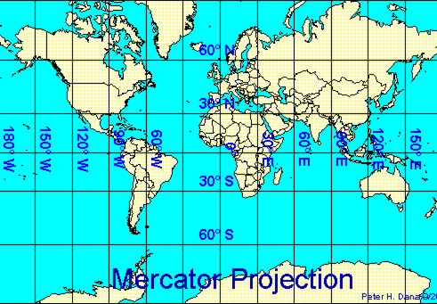

Peter H. Dana, The Geographer's Craft Project, Department of Geography, The University of Colorado at Boulder. Copyright © 1999 Peter H. Dana. <https://foote.geography.uconn.edu/gcraft/notes/mapproj/mapproj_f.html>

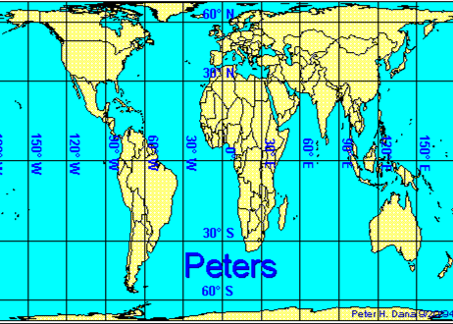

Peter H. Dana, The Geographer's Craft Project, Department of Geography, The University of Colorado at Boulder..

Copyright © 1999 Peter H. Dana. <https://foote.geography.uconn.edu/gcraft/notes/mapproj/mapproj_f.html>

**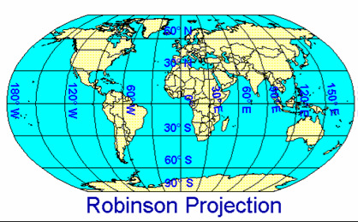**

Peter H. Dana, The Geographer's Craft Project, Department of Geography, The University of Colorado at Boulder..

Copyright © 1999 Peter H. Dana. <https://foote.geography.uconn.edu/gcraft/notes/mapproj/mapproj_f.html>

**Lesson 1**

***Student Handout 1.2—Viewing Earth from Different Vantage Points***

Your usual view of the world is a wall map centered on the equator and the prime meridian, or a globe fixed to a frame at the North and South Poles. If you were riding in a satellite orbiting Earth you would see very different views. Also, if you were standing anywhere on Earth’s surface you might think of your position as the center of the Earth. To enable you to look at the surface of the earth from different perspectives, use a freestanding globe that is not attached to a frame or Google Earth. From this site you can “spin” the globe in any direction to see the view that you want.

1. Turn the globe until you can view it with the center at the North Pole. What land masses can you see? Which are not visible at all? How are these land masses and bodies of water connected and separated? Is this part of the world inhabited by many people?
2. Turn the globe so that the south pole is in the center. Answer the same questions as in above.
3. Turn the globe so that you can view a hemisphere centered on the Pacific Ocean. What land masses can you see? What is this region often called?
4. Turn the globe to center it on 60°E, 15°N. Which continents are visible? Which bodies of water are visible? Why do you think this view of the globe has been called “The Old World?” Why might historians call this huge region a major theater of human history?
5. Turn the globe to place the Americas at the center, with the North and South Poles visible at the edge, and the Prime Meridian and International Date Lines at the eastern and western edges. What other land masses can be seen? How far toward the poles do North and South America extend? Why do you think this view of the globe has been called “The New World”? Why might historians consider this another theater of human history?
6. Would historians be likely to think of a view of earth centered on 0° and 180° as a theater of human history? Why or why not?

7. Turn the globe to place Australia at the center, so that the view is centered on the Tropic of Capricorn and 120° E longitude. What other land masses are visible? Why might this large region, which is also mostly water, be considered a theater of human history?

**Lesson 1**

***Student Handout 1.3—Theaters of Human History***

For the period from about 10,000 B.C.E. to 1500 C.E., historians can identify three primal spaces within which humans interacted. Identify and label the major land masses and bodies of water in these theaters of human history. Write a paragraph or discuss in groups why they are considered distinct regions for that period. Use the spaces next to the globes to take notes. What happened after 1500 C.E. to change the boundaries of these theaters, and how did they change?

.

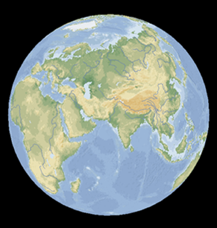

***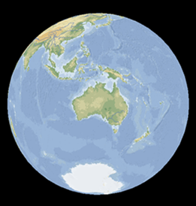***

***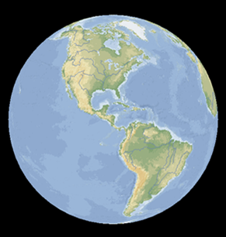***

Microsoft® Encarta® Reference Library 2002. © 1993-2001 Microsoft Corporation. All rights reserved.

***Lesson 2***

***How Many Continents Are There?***

**A lesson in four parts**

* Part 1: What is a continent?
* Part 2: Pull the plug
* Part 3: Crack the eggshell
* Part 4: Debate the conclusions

**Materials**

* Student Handouts 2.1 – 2.3
* Tracing paper
* Computer with Internet access (optional)

**Part 1: What is a Continent?**

**Procedure**

1. Have students review and prepare to critique the conventional designation of seven continents by completing Student Handout 2.1. This activity familiarizes students with the unique case of the Europe-Asia boundary, as well as the concept that the process of naming geographic features has its own historical context. For example, the Prime Meridian of longitude is located where it is because of decisions made by British leaders, not because it “naturally” belongs there.

**Part 2: Pull the Plug**

**Procedure**

1. This and the next exercise continue students’ interaction with different types of maps and different ways of viewing Earth. They work with the implications of seeing Earth is different ways for thinking about human-made divisions of the world. Student Handout 2.2 shows the seafloor relief and the continental shelves. After passing out the map handout, ask the class what they are seeing in this view of Earth. Tell them if they could pull a giant plug and let all the water out of the seas, lakes, and rivers, this is how Earth’s surface would appear.
2. Explain or solicit prior knowledge that the seafloor contains mountains as high as any on Earth and trenches several miles deep. Ask or explain about 1) the mid-ocean ridges that provide evidence of seafloor spreading, 2) molten rock that emerges along seams and that push the plates apart, and 3) deep trenches such as those along the Pacific Rim where edges of the plates have been pushed downward into the mantle. These phenomena are fundamental aspects of plate tectonics.
3. Assign students in groups or individually to investigate the seafloor map and respond to the questions on Student Handout 2.2. The first question refers to the darker and lighter shades of blue representing variations in the depth of the water. The shallow (light blue) areas around the continents represent the continental shelves that students are asked to define.
4. Provide tracing paper to allow students to draw a rough map using the continental shelves as continent boundaries. As they investigate and as the class debriefs at the conclusion of the activity, draw attention to the island chains in Southeast Asia and features such as the Caribbean Sea and the Mediterranean Sea, which no longer seem separate from the continents near them. Note which coastlines on Earth have a very wide or very narrow continental shelf. Discuss how this view supports the idea of a continent of Afroeurasia, since the three conventional regions of Africa, Asia, and Europe no longer appear separate. Also ask students to consider the idea that North and South America constitute a single land mass. Some atlases also depict the seafloor at the North Pole, which shows that North America and Asia are intimately joined.

**Part 3: Crack the Eggshell**

**Procedure**

1. Distribute Student Handout 2.3. Ask students what the earth is like at its core. Is the earth a solid sphere of rock, and what is under the surface on which we stand? (The web sites attached to the Student Handouts 2.2 and 2.3 maps provide this information if the discussion goes in that direction.) Explain to students that the earth’s crust is quite thin compared with the mantle and the core, and that it is made up, scientists now believe, of gradually shifting plates in dynamic movement.
2. Have students complete the investigation of the map and complete the activities in pairs or groups.
3. In discussing students’ findings, take advantage of the opportunity to correlate the points of collision between plates and earth’s major mountain chains. Note particularly the long chain reaching from Alaska to the tip of South America, as well as the one from the North African coast and the northern rim of the Mediterranean in Europe extending eastward across Central Asia to China. These chains correspond closely to major subduction zones, which means the action or process of the edge of one crustal plate descending below the edge of another. Another chain on the western rim of the Pacific, called the “ring of fire” because of incessant volcanic activity, traces a line of island chains from the Bering Strait to New Zealand.
4. Note the name of the tectonic plate on which Asia and Europe are located, as well as the Arabian plate that bridges between Africa and the Eurasian plates. Call attention to the direction of plate movement indicated by the arrows.

**Part 4: Debate the Conclusions**

**Procedure**

1. Assign students to write a paragraph describing how their opinions of the number of continents might have changed by looking at the topography of the ocean floor and the tectonic divisions of earth’s crust.
2. For maps of the seafloor topography combined with designations of continental plates, see recent editions of the *National Geographic Atlas of the World* or *Google Earth*.
3. After collecting the students’ views, invite them to stage a classroom debate in which students are grouped in teams with similar opinions. Ask them to argue for traditional or alternate designations of the continents, and the number of continents they believe there are.
4. After these extensive investigations of a wide range of geographic topics, students should be encouraged to assess and organize what they have learned about the earth and geography by writing in their journals or other learning record.

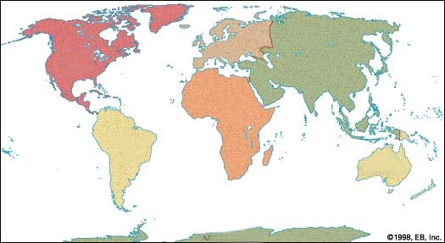**Lesson 2**

***Student Handout 2.1—What is a Continent?***

1. Identify the continents as shown on this map and label them.
2. Locate the Equator on the map and label it? What is the significance of the Equator line? \_\_\_\_\_\_\_\_\_\_\_\_\_\_\_\_\_\_\_\_\_\_\_\_\_\_\_\_\_\_\_\_\_\_\_\_\_\_\_\_\_\_\_\_\_\_\_\_\_\_\_\_\_\_\_\_\_\_\_\_\_\_\_\_\_\_\_\_\_\_\_\_\_\_
3. Locate the Prime Meridian on the map.
4. What does the prime meridian represent, and why does it run through Greenwich, England.? In what year was this line established and named, and by whom? What is meant by “Greenwich Mean Time?” Why was this placement considered logical? Could the Prime Meridian be located anywhere else on earth?

\_\_\_\_\_\_\_\_\_\_\_\_\_\_\_\_\_\_\_\_\_\_\_\_\_\_\_\_\_\_\_\_\_\_\_\_\_\_\_\_\_\_\_\_\_\_\_\_\_\_\_\_\_\_\_\_\_\_\_\_\_\_\_\_\_\_\_\_\_\_\_\_\_\_\_\_\_\_\_\_\_\_\_\_\_\_\_\_\_\_\_\_\_\_\_\_\_\_\_\_\_\_\_\_\_\_\_\_\_\_\_\_\_\_\_\_\_\_\_\_\_\_\_\_\_\_\_\_\_\_\_\_\_\_\_\_\_\_\_\_\_\_\_\_\_\_\_\_\_\_\_\_\_\_\_\_\_\_\_\_\_\_\_\_\_\_\_\_\_\_\_\_\_\_\_\_\_\_\_\_\_\_\_\_\_\_\_\_\_\_\_\_\_\_\_\_\_\_\_\_\_\_\_\_\_\_\_\_\_\_\_\_\_\_\_\_\_\_\_\_\_\_

1. Look up the dictionary or glossary definition of a continent and write a brief version here.

\_\_\_\_\_\_\_\_\_\_\_\_\_\_\_\_\_\_\_\_\_\_\_\_\_\_\_\_\_\_\_\_\_\_\_\_\_\_\_\_\_\_\_\_\_\_\_\_\_\_\_\_\_\_\_\_\_\_\_\_\_\_\_\_\_\_\_\_\_ \_\_\_\_\_\_\_\_\_\_\_\_\_\_\_\_\_\_\_\_\_\_\_\_\_\_\_\_\_\_\_\_\_\_\_\_\_\_\_\_\_\_\_\_\_\_\_\_\_\_\_\_\_\_\_\_\_\_\_\_\_\_\_\_\_\_\_\_\_ \_\_\_\_\_\_\_\_\_\_\_\_

1. Describe the defining boundaries around each continent. Which ones cut through land masses?

\_\_\_\_\_\_\_\_\_\_\_\_\_\_\_\_\_\_\_\_\_\_\_\_\_\_\_\_\_\_\_\_\_\_\_\_\_\_\_\_\_\_\_\_\_\_\_\_\_\_\_\_\_\_\_\_\_\_\_\_\_\_\_\_\_\_\_\_\_\_\_\_\_\_\_

1. Which land borders between continents are the shortest? \_\_\_\_\_\_\_\_\_\_\_\_\_\_\_\_\_\_\_\_\_\_\_\_\_\_\_\_\_\_\_\_\_\_\_\_\_\_\_\_\_\_\_\_\_\_\_\_\_\_\_\_\_\_\_\_\_\_\_\_\_\_\_\_\_\_\_\_\_\_\_\_\_\_\_
2. Where is the longest land border between any two continents? \_\_\_\_\_\_\_\_\_\_\_\_\_\_\_\_\_\_\_\_\_\_\_\_\_\_\_\_\_\_\_\_\_\_\_\_\_\_\_\_\_\_\_\_\_\_\_\_\_\_\_\_\_\_\_\_\_\_\_\_\_\_\_\_\_\_\_\_\_\_\_\_\_\_\_
3. What boundaries divides Africa from Asia? \_\_\_\_\_\_\_\_\_\_\_\_\_\_\_\_\_\_\_\_\_\_\_\_\_\_\_\_\_\_\_\_\_\_\_\_\_\_\_\_\_\_\_\_\_\_\_\_\_\_\_\_\_\_\_\_\_\_\_\_\_\_\_\_\_\_\_\_\_\_\_\_\_\_\_
4. In an atlas, find out what topographical features mark the boundary between Europe and Asia. List these features: \_\_\_\_\_\_\_\_\_\_\_\_\_\_\_\_\_\_\_\_\_\_\_\_\_\_\_\_\_\_\_\_\_\_\_\_\_\_\_\_\_\_\_\_\_\_\_\_\_\_\_\_\_\_\_\_\_\_\_\_\_\_\_\_\_\_\_\_\_\_\_\_\_\_\_\_\_\_\_\_\_\_\_\_\_\_\_\_\_\_\_\_\_\_\_\_\_\_\_\_\_\_\_\_\_\_\_\_\_\_\_\_\_\_\_\_\_\_\_\_\_\_\_\_\_\_\_\_\_\_\_\_\_\_\_\_\_\_\_\_\_\_\_\_\_\_\_\_\_\_
5. Why do you think that geographers are willing to unite Asia and Europe as a single continent named “Eurasia”?

\_\_\_\_\_\_\_\_\_\_\_\_\_\_\_\_\_\_\_\_\_\_\_\_\_\_\_\_\_\_\_\_\_\_\_\_\_\_\_\_\_\_\_\_\_\_\_\_\_\_\_\_\_\_\_\_\_\_\_\_\_\_\_\_\_\_\_\_\_\_\_\_\_\_\_\_\_\_\_\_\_\_\_\_\_\_\_\_\_\_\_\_\_\_\_\_\_\_\_\_\_\_\_\_\_\_\_\_\_\_\_\_\_\_\_\_\_\_\_\_\_\_\_\_\_\_\_\_\_\_\_\_\_\_\_\_\_\_\_\_\_\_\_\_\_\_\_\_\_\_

**Lesson 2**

***Student Handout 2.2—Pull the Plug***

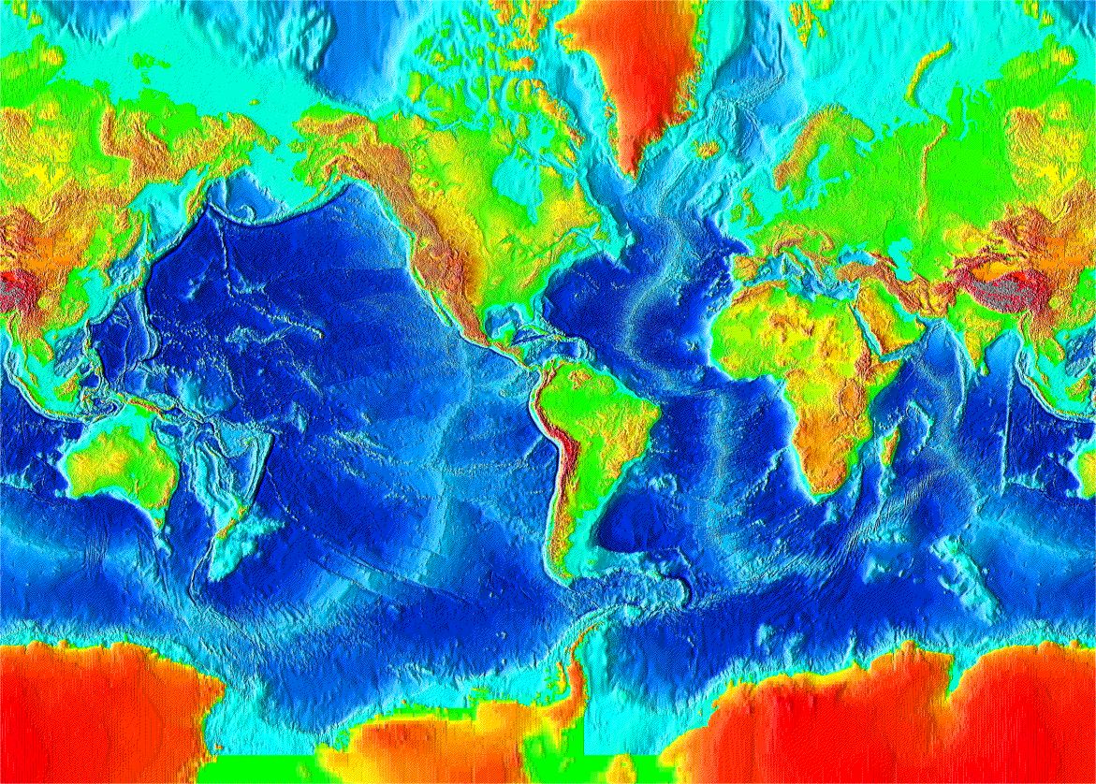Pretend the earth is a bathtub, and you just pulled the plug. When the seas have all been drained out, view the map of earth’s topography, below.

[Karen Grove](http://geosci.sfsu.edu/faculty/grove/personal/home.html) (©1998, 2001 Grove) for use in the [Introduction to Oceanography Laboratory](http://geosci.sfsu.edu/courses/geol103/labs/labs.html) course at [San Francisco State University](http://tornado.sfsu.edu/)).

Look at the differing shades of blue on the map and describe what they represent. Find a definition for the areas represented by the lightest blue color.

As you know, over the long run of Earth’s history, the level of the seas has not always been the same. During the Ice Ages, when water was locked up in huge polar ice caps, sea level was so much lower that a land bridge existed between Asia and North America. Use this map to form a new view of the continents we know from maps showing all the water in place. Make a sketch or use tracing paper to draw a new map of Earth’s continents in which the edge of the continental shelf is the continental border. Answer the questions below.

* According to this way of looking at the world, how many continents are there?
* Where else on Earth might land bridges have existed during the Ice Ages? Verify that land bridges existed in the regions chosen.
* How does the appearance of the Caribbean Sea change in this view?
* What is the relationship between Asia and Australia, and what lands lie between them?
* What is the relationship between Asia and North America?
* Could you argue that the Mediterranean is an inland sea within a huge landmass? Why or why not?
* Does this map support the idea of a continent called Afroeurasia?

**Lesson 2**

***Student Handout 2.3—Crack the Eggshell***

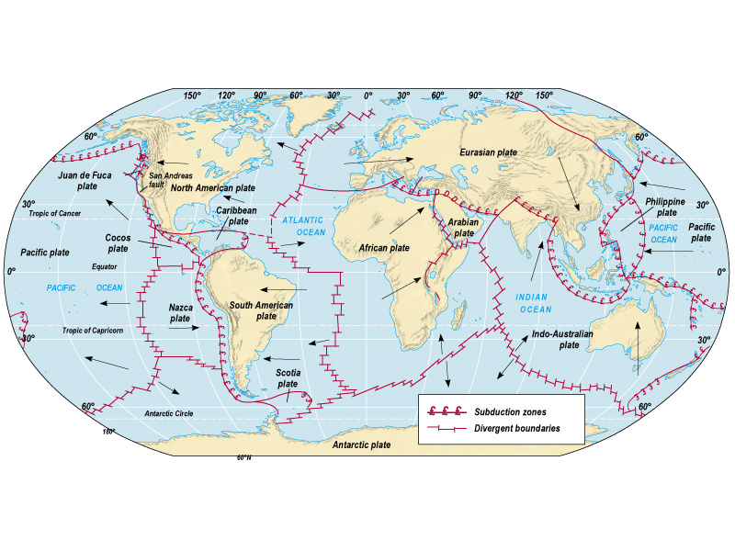University of Texas, Department of Geography and the Environment, Paul F. Hudson, The Natural Environment: An Introduction to Physical Geography/GRG 301

Using the map key, locate and explain what the two different types of red lines represent. (Hint: use a dictionary or encyclopedia.)

Do the following activities to provide another view of the continents and their boundaries.

* The theory of plate tectonics explains the occurrence of earthquakes and volcanoes, as well as the phenomenon of continental drift. Explain the basic principles of plate tectonics.
* Locate major earthquake zones in each of the following regions: Pacific Ocean, Indian Ocean, Mediterranean Sea, North America, and South America. Recall or research recent earthquakes along any of these lines. (Find dates and place names and associate them with the lines on the map.)
* Make a list of the plates that make up Earth’s crust and write the name of the continents and subcontinents that ride on each.
* What is the relationship between subduction zones and Earth’s major mountain chain and island chains off the east and southeast coasts of Asia?
* Cut on the red lines to make a puzzle. How many puzzle pieces do you have? Mix up the pieces and, working with a partner, try to reassemble them. Glue your result to a piece of paper.

***Lesson 3***

***The Personality of Earth’s Surface***

**A lesson in three parts**

* Part 1: In the zones—plants, animals, and people
* Part 2: Moving on the continental axes
* Part 3: Inside and outside: Afroeurasian waterways

**Materials**

* Handouts 3.1- 3.4
* Computer Internet access (optional)
* Classroom atlases
* Wall map of the physical Earth (optional)

**Part 1: In the Zones—Plants, Animals and People**

**Procedure**

1. Introduce the three types of maps placed in Student Handout 3.1. Have students work in pairs or small groups. It may be helpful to discuss how climate and vegetation maps correlate and get students started by filling in one line of the chart as an example.
2. When students have finished, discuss the difficulties they found in making the correlations on climate and vegetation. Ask them to give examples of plants and animals that live in each zone, and how humans use both as resources in those places.

**Part 2: Moving on the Continental Axes**

**Procedure**

* 1. Having set up students with the necessary information base to understand Jared Diamond’s concept of latitudinal and longitudinal axes of continents and diffusion. It should not be difficult to use the diagrams to bring the ideas to discussion. Have them view the map and carefully read the quotation on Student Handout 3.2 from Jared Diamond, *Guns, Germs, and Steel* to approach understanding of the concept.
  2. It may be practical to respond to the questions on Student Handout 3.2 as a whole class activity. Have students refer to the climate and vegetation maps and chart, and use the physical wall map in the classroom or atlas. Encourage students to support their answers with evidence. Try to draw out what they may have learned in science and geography classes in earlier years of school. Some of the questions will be raised and considered rather than answered. Students should be encouraged to note these questions for reference later in the course.

1. Ask students for their prior knowledge of latitudinal movements across Africa and the Americas in history. These questions may, of course, be raised now but only answered in the course of the coming year of world history study. Therefore, this lesson becomes a question or theme to carry through the year. Examples may include the spread of indigenous American groups before 1500 CE or sub-Saharan migrations in Africa. For modern examples, invasive species brought by colonizers and shipping companies, global food trade as a carrier of microorganisms such as West Nile virus, Avian flu, or AIDS.

**Part 3: Inside and Outside—Afroeurasian Waterways**

**Procedure**

1. Student Handout 3.3 is a review and identification opportunity, but it is also intended to illustrate how complex the coast of Europe (or western Eurasia) is, with its many bays, seas, and peninsulas. Using classroom atlases, have students identify and label the bodies of water. Because of space considerations, a numbered key may be easier than labeling.
2. When students have completed labeling, discuss the effects of these interior waterways on communication, maritime migration, warfare, trade, and fishing. Discuss how the bodies of water within the dotted oval on the map are external routes to larger bodies of land and water, as well as interior seas. Ask students to recall from prior knowledge how these bodies of water have connected people together and linked Europe to other parts of Afroeurasia. Ask in what ways the Red Sea and the Persian Gulf are part of the system of interior waterways.
3. Student Handout 3.4 carries this theme further, demonstrating how the coastal waterways linked all of Afroeurasia’s western and southern warmwater seas. Using the imaginary voyage, have students identify the waterways, locate them on the map, and connect them together. Some students will trace the route across northern Eurasia, so it may be necessary to help these students consider the climate factor and other possible obstacles. (Compare the northern trans-Eurasian route to the Northwest Passage across the northern regions of North America).

**The “eleven seas” to be identified from northwest to east are: Baltic Sea, North Sea, northeastern coastal Atlantic, Mediterranean Sea, Red Sea, Persian Gulf, Arabian Sea, Bay of Bengal, South China Sea, East China Sea, Sea of Japan. (The Red Sea and the Persian Gulf are parallel alternative routes.)**

1. Using online resources, locate maps of global shipping. Use a world history textbook map showing medieval trade routes of the Indian Ocean, Mediterranean Sea, the Atlantic coastal region, and the overland routes, including the Silk Roads. Compare the use of the waterways on Student Handout 3.4
2. Have students locate the major rivers on each continent using Handout 3.5 and a classroom atlas or wall map. Identify the watersheds of these rivers and the direction of flow. Assign individuals or volunteers to do mini-research projects on the navigability of these rivers.
3. Identify and locate the cities students associated with the rivers and assess their importance today and in the past, soliciting students’ prior knowledge. Note any correlation with rivers that flow through dry climate regions and deserts as exceptions to the population density trends in the last lesson. Identify these major rivers and the cities associated with them, historically and today.
4. Refer to these rivers and instruct students to keep the worksheets and maps from this lesson handy for future reference in their world history course.

**Lesson 3**

***Handout 3.1—Climate, Plants, and People***

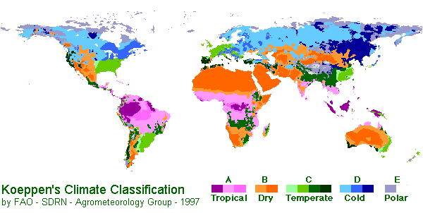

This map appears on a site developed and created by Elisabeth Benders-Hyde, a science teacher at the West Tisbury School, Martha’s Vineyard, Massachusetts. It evolved from a biome project created by Ann and Karl Nelson. <Http://www.blueplanetbiomes.org/climate.htm>.

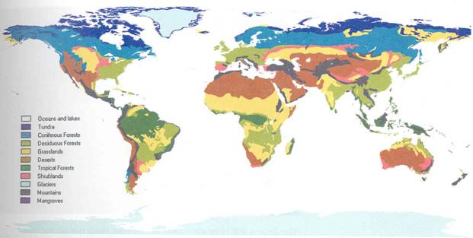**Vegetative Biomes (Ecosystems) of the World**

Global Ecosystems Database Version 2.0, NOAA National Geophysical Data Center, by permission from P. & J. Kineman, GAIA Institute of Geographical Ecology, Boulder CO)

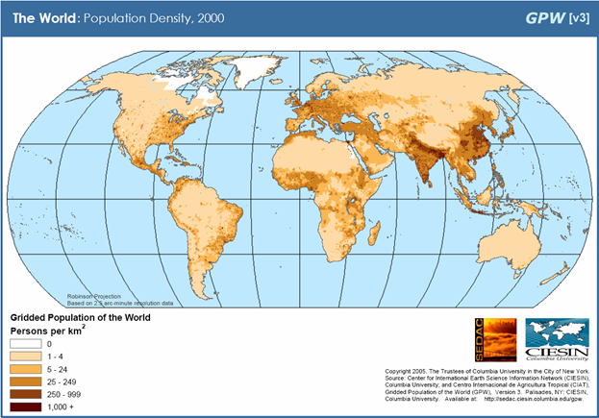

Socioeconomic Data and Applications Center, Columbia University (<http://sedac.ciesin.columbia.edu/gpw/index.jsp>)

Match the corresponding climate classifications to the biome classifications (Some will overlap.)

|  |  |
| --- | --- |
| **Climate Classification** | **Vegetative Biome (Ecosystem)** |
|  |  |
|  |  |
|  |  |
|  |  |
|  |  |
|  |  |
|  |  |
|  |  |
|  |  |
|  |  |
|  |  |
|  |  |
|  |  |

Which vegetation zones correlate to the highest population density?

Which vegetation zones correlate to the lowest population density?

Can you locate any areas that show high human population density in areas of low vegetation and dry or cold climate? List them.

Why do you think these areas form an exception to the global trend?

How have humans overcome the climate conditions to live closely packed in such regions? Which of these areas have major rivers?

**Lesson 3**

***Student Handout 3.2—Moving on the Continental Axes***

****

The following quotations are taken from Jared Diamond’s book *Guns, Germs, and Steel: The Fates of Human Societies* (New York: W.W. Norton, 1999), pages 176-189. These quotations summarize his ideas about the relationship of the geographic axes of the continents (as conventionally defined) to differences in human technological development. For more information, read Diamond’s book, Chapter 10, “Spacious Skies and Tilted Axes.”

On the map of the world, compare the shapes and orientations of the continents. You’ll be struck by an obvious difference. The Americas span a much greater distance north-south (9,000 miles) than east-west: only 3,000 miles at the widest. . . . That is, the major axis of the Americas is north-south. The same is also true . . . for Africa. In contrast, the major axis of Eurasia is east-west. What effect, if any, did those differences in the orientation of the continents’ axis have on human history?

Axis orientations affected the rate of the spread of crops and livestock, and possibly also of writing, wheels, and other inventions. That basic feature of geography thereby contributed heavily to the very different experiences of Native Americans, Africans and Eurasians in the last 500 years.

Just as some regions proved much more suitable than others for the origins of food production, the ease of its spread also varied greatly around the world. . . . At the one extreme was its rapid spread along east-west axes: from Southwest Asia both west to Europe and east to the Indus Valley; . . . and from the Philippines east to Polynesia. . . .At the opposite extreme was its slow spread along north-south axes: . . . from Mexico northward to the U.S. Southwest . . . [to] the eastern United States . . . from Peru north to Ecuador.

Why was the spread of crops from the Fertile Crescent so rapid? . . . Localities distributed east and west of each other at the same latitude share exactly the same day length and seasonal variations. To a lesser degree, they also tend to share similar diseases, regimes of temperature and rainfall, and habitats or biomes (types of vegetation) . . . the germination, growth, and disease resistance of plants are adapted to precisely those features of climate. Seasonal changes of day length, temperature, and rainfall constitute signals that stimulate seeds to germinate, seedlings to grow, and mature plants to develop flowers, seeds and fruit. . . . Animals too are adapted to latitude-related features of climate.

Thus, Eurasia’s east-west axis allowed Fertile Crescent crops quickly to launch agriculture over the band of temperate latitudes from Ireland to the Indus Valley. . . . Contrast the ease of east-west diffusion in Eurasia with the difficulty of diffusion along Africa’s north-south axis. . . . Similarly, the spread southward of Fertile Crescent domestic animals throughout Africa was slowed by climate and disease.

Contrast also the ease of diffusion in Eurasia with its difficulties along the America’s north-south axis. The distance between Mesoamerica and South America . . . is only 1,200 miles, approximately the same distance in Eurasia separating the Balkans from Mesopotamia. . . . But other crops and domestic animals failed to spread between Mesoamerica and South America. The cool highlands of Mexico would have provided ideal conditions for raising llamas, guinea pigs, and potatoes, all domesticated in the cool highlands of the South American Andes. Yet the northward spread of those Andean specialties was stopped completely by the hot intervening lowlands of Central America.

Latitude . . . is a major determinant of climate, growing conditions, and ease of spread of food production. However, latitude is of course not the only determinant, and it is not always true that adjacent places at the same latitude have the same climate. . . Topographic and ecological barriers . . . were locally important obstacles to diffusion.

**Study Questions**

1. Compare the map of Earth’s major climate zones (tropical, temperate, arctic) with the world biomes map and with the map showing axes of the inhabited continents above. How many biological and climate zones would a person, plant, or animal have to cross going from point A to B on the map? From C to D? From E to F?
2. Why might it be easier for plants, animals, and people to migrate within the same or similar biomes and climate zones than to cross between very different zones? Which of the three life forms is most adaptable? What if we include microorganisms?
3. Give examples of plant, microorganism, animal, and human migrations you have learned about that involved long distances. Was the crossing of the Alaska/Eurasia land bridge that historians believe helped populate the Americas with people from Eurasia an east-west migration or a north-south migration? What about diseases and insects?

**Assessment**

Using evidence from these maps, write a paragraph explaining the quotations from Jared Diamond’s *Guns, Germs, and Steel*. Use supporting evidence from your study of various types of maps.

**Lesson 3**

***Student Handout 3.3—Inside and Outside: Afroeurasian Waterways***



Label these seas in their proper locations on the map above:

|  |  |
| --- | --- |
| Baltic Sea | North Sea |
| Caspian Sea | Persian Gulf |
| Black Sea | Red Sea |
| Mediterranean Sea |  |

Which waterways connect with others?

Which bodies of water are landlocked?

Use a classroom atlas or wall map to identify and label (using numbers or arrows) the straits and channels that link these waterways.

Which man-made waterway links the Red Sea and the Mediterranean today? When was it built?

**Lesson 3**

***Student Handout 3.4—The Eleven Seas of Afroeurasia***

The nineteenth century was a time when many artists and poets were fascinated by maritime journeys and exotic places. Many of these references appeared in lighthearted poems for children that became classics. The lines below are from *The Owl and the Pussy-Cat* by British poet Edward Lear (1812-1888). Imagine a fantastic voyage like this one as you learn about the geography of Afroeurasia.

*The Owl and the Pussy-Cat went to sea  
In a beautiful pea-green boat:  
They took some honey, and plenty of money  
Wrapped up in a five-pound note…  
They sailed away, for a year and a day,  
To the land where the bong-tree grow…  
They dined on mince and slices of quince,  
Which they ate with a runcible spoon;  
And hand in hand on the edge of the sand…*

*They danced by the light of the moon.*

Can you trace a journey by sea undertaken by this famous poetic pair, which starts at the northernmost point of the Baltic Sea and ends in the Sea of Japan?

What two routes are possible? Which route might be blocked either all or most of the year? By what?

Which route has the smallest obstacle to passage? Is that passage open today? How might it have been crossed before 1869 CE when an artificial waterway named the \_\_\_\_\_\_\_\_\_\_\_\_\_\_\_\_\_ was completed?

Which journey would the Owl and the Pussycat be most likely to survive? Mark the route with a line.

Using an atlas, list the eleven seas, bays, and gulfs in Afroeurasia that the Owl and the Pussycat would pass through. Using the map on the next page, label those bodies of water on the map key, then place the corresponding number on the appropriate spot on the map.

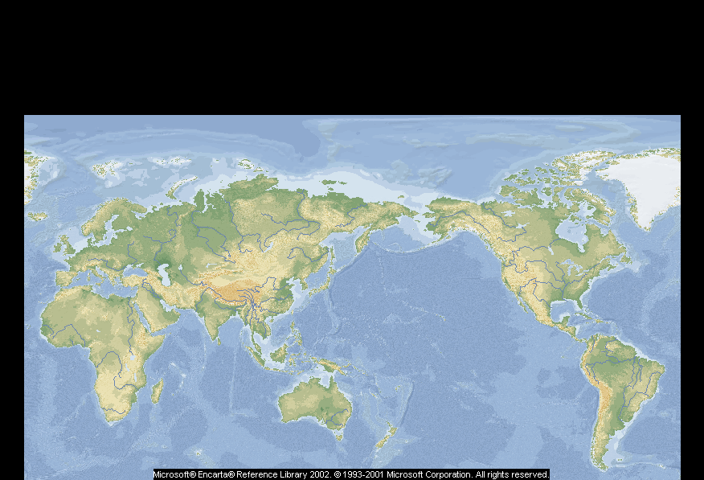

**Map Key**

**Afroeurasia’s Eleven Seas**

1\_\_\_\_\_\_\_\_\_\_\_\_\_\_\_\_\_\_\_\_\_\_\_\_\_\_\_\_\_\_\_\_\_\_\_\_\_

2\_\_\_\_\_\_\_\_\_\_\_\_\_\_\_\_\_\_\_\_\_\_\_\_\_\_\_\_\_\_\_\_\_\_\_\_\_

3\_\_\_\_\_\_\_\_\_\_\_\_\_\_\_\_\_\_\_\_\_\_\_\_\_\_\_\_\_\_\_\_\_\_\_\_\_

4\_\_\_\_\_\_\_\_\_\_\_\_\_\_\_\_\_\_\_\_\_\_\_\_\_\_\_\_\_\_\_\_\_\_\_\_\_

5\_\_\_\_\_\_\_\_\_\_\_\_\_\_\_\_\_\_\_\_\_\_\_\_\_\_\_\_\_\_\_\_\_\_\_\_\_

6\_\_\_\_\_\_\_\_\_\_\_\_\_\_\_\_\_\_\_\_\_\_\_\_\_\_\_\_\_\_\_\_\_\_\_\_\_

7\_\_\_\_\_\_\_\_\_\_\_\_\_\_\_\_\_\_\_\_\_\_\_\_\_\_\_\_\_\_\_\_\_\_\_\_\_

8\_\_\_\_\_\_\_\_\_\_\_\_\_\_\_\_\_\_\_\_\_\_\_\_\_\_\_\_\_\_\_\_\_\_\_\_\_

9\_\_\_\_\_\_\_\_\_\_\_\_\_\_\_\_\_\_\_\_\_\_\_\_\_\_\_\_\_\_\_\_\_\_\_\_\_

10\_\_\_\_\_\_\_\_\_\_\_\_\_\_\_\_\_\_\_\_\_\_\_\_\_\_\_\_\_\_\_\_\_\_\_\_

11\_\_\_\_\_\_\_\_\_\_\_\_\_\_\_\_\_\_\_\_\_\_\_\_\_\_\_\_\_\_\_\_\_\_\_\_

**Lesson 3**

***Student Handout 3.5—Earth’s Rivers: Highways into the Continents***

Identify each of the major rivers shown on the map and write its name in the correct box.

What is a watershed? Name three rivers that have watersheds draining large parts of each continent.

What makes a river navigable? What prevents a river from being navigable?

Name one major city on each of the rivers you labeled on the map.

|  |  |  |  |
| --- | --- | --- | --- |
| **River** | **City** | **River** | **City** |
|  |  |  |  |
|  |  |  |  |
|  |  |  |  |
|  |  |  |  |
|  |  |  |  |
|  |  |  |  |
|  |  |  |  |

**This unit and the Three Essential Questions**

|  |  |
| --- | --- |
| envir_icon | How have physical or natural features of the earth affected people’s capability of communicating over long distances? What physical or natural features might prevent or hinder transport? |
| humans_icon | How might concepts and perceptions of geographic space affect the perceptions and attitudes of the people of one country toward the people of another? |
| ideas_icon | If a continent is defined as a large land mass surrounded, or almost surrounded by water, how do you imagine that Europe, which is not surrounded by water, came to be categorized as a continent? Who might have decided that there are seven continents and that Europe is one of them? Was a different definition used to identify Europe as a continent? Should Europe be recategorized as a subcontinent, parallel, say, to South Asia? Teachers and students may wish to refer to Martin W. Lewis and Kären E. Wigen, *The Myth of Continents* (Berkeley: University of California Press, 1997). |

**This Unit and the Standards in Historical Thinking**

Historical Thinking Standard 2: Historical Comprehension

The student is able to (F) draw upon data in historical maps in order to obtain or clarify information on the geographic setting in which the historical event occurred, its relative and absolute location, the distances and directions involved, the natural and man-made features of the place, and critical relationships in the spatial distributions of those features and the historical event occurring there.

The student is about to (G) draw upon the visual and mathematical data presented in graphs, including charts, tables, pie and bar graphs, flow charts, Venn diagrams, and other graphic organizers to clarify, illustrate, or elaborate upon information presented in the historical narrative.

Historical Thinking Standard 3: Historical Analysis and Interpretation

The student is able to (G) consider multiple perspectives in the records of human experience by demonstrating how their differing motives, beliefs, interests, hopes, and fears influenced individual and group behaviors.

The student is about to (H) explain causes in analyzing historical actions, including (a) the importance of the individual in history, of human will, intellect, and character; (b) the influence of ideas, human interests, and beliefs; and (c) the role of chance, the accidental, and the irrational.

Historical Thinking Standard 4: Historical Research Capabilities

The Student is about to (A) formulate historical questions from encounters with historical documents, eyewitness accounts, letters, diaries, artifacts, photos, historical sites, art, architecture, and other records from the past.

The student is able to (C) interrogate historical data by determining by whom and when it was created; testing the data source for its credibility, authority and authenticity; and detecting and evaluating bias, distortion, and propaganda by omission, suppression, or invention of facts.

Historical Thinking Standard 5: Historical Issues-analysis and Decision-making

The student is about to (A) Identify issues and problems in the past and analyze the interests, values, perspectives, and points of view of those involved in the situation.

**Resources for Teachers and Students**

Black, Jeremy. *Maps and History: Constructing Images of the Past*. New Haven, CT: Yale UP, 1997.

Christian, David*. Maps of Time: An Introduction to Big History*. Berkeley: University of California Press, 2004.

Diamond, Jared. *Guns, Germs and Steel : The Fates of Human Societies*. New York: W. W. Norton, 1997.

Dunn, Ross E. and Laura J. Mitchell. *Panorama: A World History*. New York: McGraw-Hill Education, 2015. See “Introduction: World History’s Theater,” 2-17.

Lewis, Martin W., and Kären E. Wigen. *The Myth of Continents: A Critique of Metageography*. Berkeley: University of California Press, 1997.

Lizard Point Quizzes. Test Your Geography Knowledge at Lizard Point. https://lizardpoint.com/. Interactive quizzes on geographical knowledge.

Monmonier, Mark. *How to Lie with Maps*. Chicago: University of Chicago Press, 1991.

Monmonier, Mark. *Rhumb Lines and Map Wars: A Social History of the Mercator Projection*. Chicago: University of Chicago Press, 2004.

Farndon, John. *Dictionary of the Earth* (Cover title: *DK Concise Encyclopedia: Earth*). London: Dorling Kindersley, Ltd., 1994.

Spier, Fred. *The Structure of Big History: From the Big Bang until Today*. Amsterdam: Amsterdam University Press, 1996.

**Conceptual links to other teaching units**

This unit forms part of the foundation of the World History for Us All curriculum. It provides for students to review their geographic knowledge and gain a world-historical orientation to geography that challenges a simplistic view of earth’s topography. There are many opportunities to link with students’ prior knowledge of earth and life science to help them understand the stage on which human history takes place.