Getting Started

Landscape Teaching Unit 0.1
Getting Our Bearings: Maps of time, space, and history

Table of Contents
Why this unit? | 2
Unit objectives | 3
Time and materials | 3
Author | 4
The historical context | 4
This unit and the Big Era timelines | 4
Lesson 1: Cartography and chronography (maps and timelines)  tat | 5
Lesson 2: Maps of space | 11
Lesson 3: Maps of time | 19
Lesson 4: Maps of history | 24
This unit and the Three Essential Questions | 27
This unit and the Standards in Historical Thinking | 27
Resources | 27

Why this unit?
There is a story about five blind men and an elephant. Each of the men feels different parts of the elephant and so each comes away with a different, and incomplete, view of what an elephant must be like. If we think of the “elephant” as being the story of humans, the analogy has to change just a little in order for it to come out right. Instead of five blind men, a student is the examiner equipped with different tools of investigation. First, the student has a magnifying glass, which allows for a very close examination of the animal’s skin cell structure, hair follicles, or tooth wear. Next, the student moves back a little, using just the eyes and seeing that the elephant is more than just the components of skin, hair, or teeth. The elephant is actually composed of all of these elements to create a large animal. The student’s next tool is a very tall ladder. From that perspective the student can see for miles around, even whole herds of elephants, as well as gazelles, lions, grasslands, rivers, and maybe human beings.

Maps are a daily part of our lives, giving us tools (of a manageable size) to see where we are in relation to other things. These tools, though, are drawn to different scales depending on the level of precision we are dealing with. A city street map is a perfect tool to get to that new Cantonese restaurant in town that people are talking about. But it is useless for seeing where the Cantonese food style originated. We need a map of far larger scale to do that. In this unit students are introduced to the idea of scale and how it can be shifted to give a general impression or to give a very detailed understanding of a slice of time or space. It is particularly important for students to understand that one perspective is not “better” than another. Each perspective simply provides a different level of detail, and each is more suited to a particular topic. Take, for example, a late eighteenth-century European document that explains a court decision. Using a high-powered magnifying glass from our world history toolbox allows us to examine closely subjects such as the literary style of the document itself, or perhaps (with a less powerful glass) the author of the document and the proceedings which resulted in the writing of the document. Laying aside the magnifying glasses, it is possible to see the society whose laws are being applied and thus some of the cultural values of that society. In a panoramic view of the document, we may see the Enlightenment, as well as the very early stages of industrialization and increasing commerce, all of which would have a profound impact on concepts of law and society.

In working with the interactions of space and time, it is important for students to understand that the scales of both are independent of each other. That is, one can use a very small scale of space, such as a single small valley in an African country, and use a very large scale of time, such as two millennia, to investigate the history of that valley. In doing so, one has the opportunity to view environmental shifts, perhaps the arrival of humans, the establishment of villages or towns, the disappearance of villages or towns—whatever may have occurred there over that period of time. At the same time, it is possible to consider the universal implications of the single nanosecond that occurred after the “Big Bang.”

The World History for Us All project is structured in a way that builds changing perspective into the lessons. As the Teaching Units section of the web site explains, each teaching unit is categorized according to one of three levels of historical scale in time and space.

Panorama Teaching Units. These units address very large-scale developments in world history.

Landscape Teaching Units. These units focus on relatively large-scale developments in world history, though not as broad in subject matter as the Panorama units.
Closeup Teaching Units. These units address topics in world history that are relatively more restricted in time than either Panorama or Landscape units.

This curriculum describes three reasons for learning world history: to know who we are, to be prepared to live in the world, and to attain cultural literacy on a world scale. In order to help students understand themselves simultaneously as individuals, as sons or daughters, as citizens, and as humans, it is important to develop the skills of shifting perspectives on the past and present. With these skills, students will see the connections between themselves and ever-expanding groups, times, and places and so will be better suited to see where humanity has been and where it is headed. For a more detailed explanation of this system see Home Page > Teaching Units > Organization and Index.

Unit objectives
Upon completing this unit, students will be able to:
- Describe three basic perspectives in relation to time, space, and history.
- Select and apply an appropriate perspective when given a specific historical topic.
- Understand and apply concepts of scale and proportion.
- Demonstrate mapping skills.

Time and materials
This Teaching Unit is divided into four lessons. Lessons 1 and 4 should take about 45 minutes of class time. Lessons 2 and 3 may take longer. The lessons can be expanded or abbreviated according to need by shortening or deleting activities, repeating activities (as described in the lessons), or engaging students in a dialogue about the topic.

The lessons described below require the following materials:
- Photocopies of student handouts
- Transparencies of the Teacher Tools (if an overhead projector is being used)
- Quarter-inch graph paper.
It is recommended that teachers obtain a directional compass and post signs of “North,” “East,” “South,” and “West” on the classroom walls. Cards are provided in this Teaching Unit for timelines, though teachers may wish to create their own. A 20-foot (6m) length of clothesline is used in Lesson 2. A 20-foot section of wall space may be substituted for the clothesline. Some teachers may find it visually useful to have three lengths of clothesline or wall space so that the timelines can be directly compared during discussions.

Author
Ian Kelly holds a PhD in history from the University of Aberdeen, Scotland. He has taught world history in the Palomar Community College District in San Diego County, California. Along with his specialty in military history, his work encompasses concepts of group identity and nationalism.

The historical context
In this unit we are not dealing with a specific historical issue but with concepts of history. We can view history from “real-time” speed down to the glacial pace of eras and eons. We can also view on spatial scales from the cosmos down to a small sheep field. In order for students to become adept at historical thinking, they need to be able to work with different historical scales in time and space.

Lesson 1

Cartography and Chronography: Maps and Timelines

Preparation
Since this lesson is expository, teachers can expect to approach this as a “lecture” lesson, though good opportunities for visual, aural, and kinetic learning will present themselves. Copies of student handouts will be needed, as well as quarter-inch (5mm) graph paper. Be aware, especially with younger students (younger than 11 or 12), that their understanding of time and sequencing is not always fully developed. Therefore, special attention to this issue may be needed.

Introduction
The term “cartography” was not used until 1859, though “chronography” has been around for nearly 500 years. Even so, humans have been describing relationships in time and space for thousands of years. Maps are important to us because they tell us where we are, where other things and people are (or were), and what our relationship to those other things and people is. In order to understand these tools, students need to have a basic understanding of how they are constructed.

Activity: Introduction to cartography and chronography
I. Basics

A. What do maps do for us? Why do we have them?

B. Do all maps show the same thing?

C. Cartography: the art of making maps

D. Chronography: the art of arranging historical events

E. Both cartography and chronography help to document relationships of time and space.

II. Elements of Maps

A. Discuss the key elements of all maps

- Title: Why a title? Isn’t it obvious what the map shows?

- Legend: What information does this provide?

- Scale: What information does this provide? Why is it important?

- Compass: Why is orientation important?
- Points of reference (often latitude and longitude, or hash-marks on a timeline to show increments of time)

B. Student Handout 1.1 allows students to work independently on map comprehension.

C. Chronography: Working individually, have students prepare three chronographs, each ten inches long. One should reflect their personal activities on the previous day, a second documenting their entire lives, and a third showing city/national/world events in the previous century. Discuss the differences between the three in terms of scale, precision, and detail.

Assessment
This lesson provides several points of assessment. Informally, student progress can be gauged according to their participation in the classroom discussions. More formally, Student Handout 1.1 and their maps can be submitted for assessment or a simple quiz can be used.
Lesson 1

Student Handout 1.1—Cartography and Chronography

From your discussion in the classroom, what are the five elements of a map?

The map on the page below shows certain developments in World War I.

Identify the five elements of a map by circling and labeling each one.

1.
2.
3.
4.
5.

Are all of the elements shown? If one is missing, which one is it?

Why might the cartographer have left it out?

It seems like it would be a lot easier to read maps if they all used the same legend, scale, and orientation. Why do cartographers have to include the basic elements for every single map?

Regions Where Significant Fighting Took Place in World War I

1 Western European Front | 5 Palestine/Syria | 9 German Cameroons
2 Eastern European Front | 6 Iraq | 10 German East Africa
3 Italian Front | 7 Arabia | 11 German Southwest Africa
4 Balkan Front | 8 German Togoland | 12 German Pacific Islands

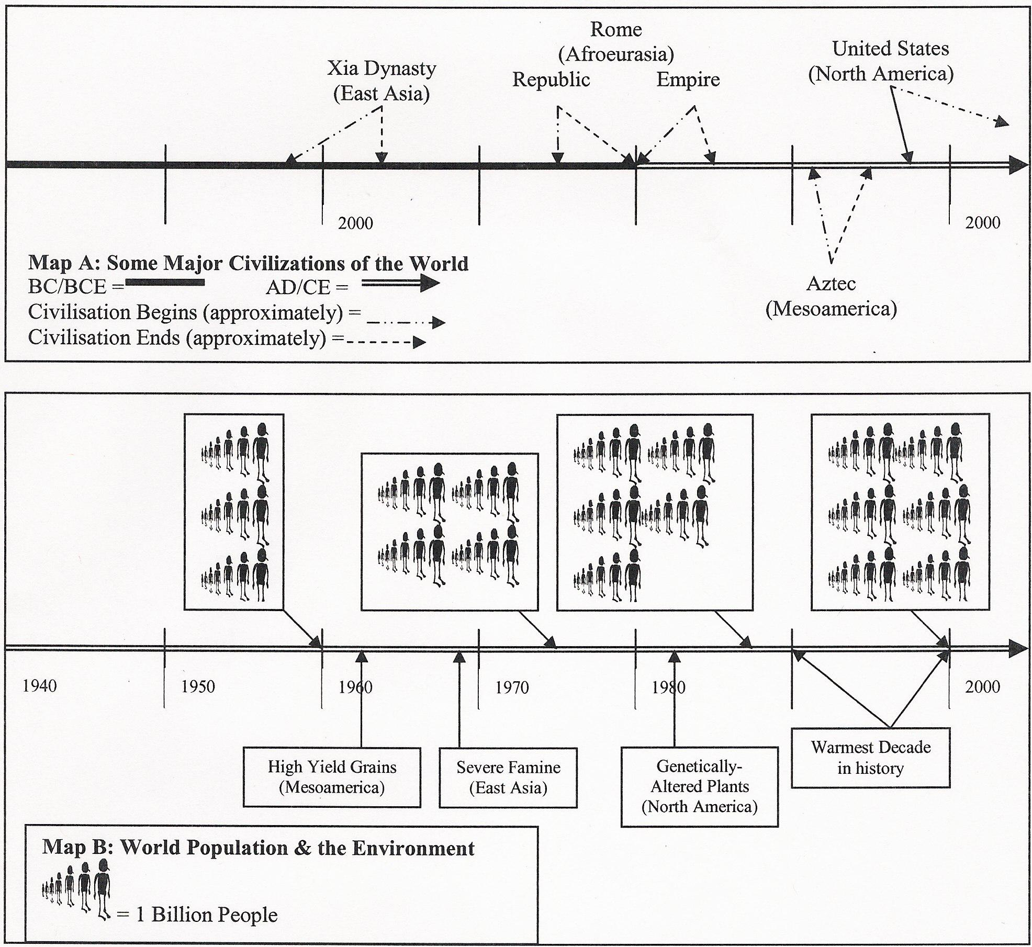
Review the timelines given below and answer the questions:

Each of the timelines above has hash-marks (vertical lines) one-inch apart. How much time is represented between the marks in Map A?__________ In Map B?__________

About how long did the Xia dynasty last?__________ The Roman Republic?__________

Estimate the year that the world population reached 5,000,000.__________

Take a look at the arrows related to the United States. The first one touches the timeline in about 1776, the year the Thirteen Colonies declared their independence from Britain. The second arrow does not touch the timeline at all. What might that represent?

Lesson 2

Maps of Space

Preparation
This lesson lends itself nicely to students being up and moving in the classroom or around campus, as well as working on their artistic or drawing skills. The first half of this lesson will require quarter-inch graph paper. If teachers have open space available (such as a playground or field), they should consider having another adult to help with the outdoor version of “What Do You See?” If the teacher opts for the indoor version (option 1) of this activity, an overhead projector will be needed, along with the transparencies of Teacher Tools 1 through 4. For the indoor version (option 2), the class will need a large photo mosaic poster. There is computer software to help generate these, or perhaps they can be purchased.

Introduction
Understanding spatial and chronological relationships is crucial to understanding historical developments. Polynesia and the Mediterranean region, for example, developed in very different ways from the Amazon basin or Inner Eurasia because of their differing geographical settings. In this lesson, students will explore how to shift scales based on the subject at hand. It is vital for students to understand that each perspective is a tool. There is no value judgment about one being “better” than another. They simply give different information.

Activity: Perspectives on Space

I. What Do You See? The Outdoor Version

- Take the class outside to a ball field, playground, or any open space that gives you at least 100 yards of clear view. Each student should have Student Handout 2.1, a pen/pencil, and something hard to use as a portable desk (notebook, text book, etc.)

- Have the other adult go to the far end of the field. This person is the “subject” of your study. Focusing on the subject, give the students a few minutes to complete the first section of Student Handout 2.1.

- Have the subject move closer to the student, perhaps halfway between them and the position they had taken above. Again focusing on the subject, give the students a few moments to complete the second section of Student Handout 2.1.

- Have the subject move to stand among the students. Again focusing on the subject, give the students a few moments to complete the third section of Student Handout 2.1.

- Return to the classroom. Discuss the questions raised in the final section of Student Handout 2.1 (Note: depending on time or other considerations, this section can be alternatively used as an assessment.)

II. What Do You See? The Indoor Version (Option 1)

A. With an overhead projector turned off, lay Teacher Tool 2.1 on the projector, then turn it on. (You may wish to conceal the questions and information provided below each image.)

B. Ask students to describe what they see and to draw any conclusions they can from what they see. Turn the projector off.

C. Remove Teacher Tool 2.1 and replace it with Teacher Tool 2.2. Turn the projector on and repeat step B above.

D. Remove Teacher Tool 2.2 and replace it with Teacher Tool 2.3. Turn the projector on and repeat step B above.

E. Discuss the differences and similarities between each of the three perspectives, eliciting views on the positive aspects of each, as well as the negative side. (It is worth mentioning that even Teacher Tool 2.3 is incomplete; there were other things that the photographer could see but that did not fall within the camera’s frame.)

III. What Do You See? The Indoor Version (Option 2)

A. Obtain a large photo mosaic poster and post it at the front of the room.

B. Talk with students about what they see from their seats and what the poster represents.

C. Invite a student (or several students) to come closer to the poster, perhaps six to ten feet from the poster. Is the image that they saw at their seats still as sharp and clear? What has changed?

D. Invite one or more students to come right up to the poster, so that their nose is almost touching it. Now what do they see? Can they still see the image they saw at their desk? Why not? What do they see now that they did not see before?

E. Talk with the students about how the long view and the closeup both give different, but still cohesive, understandings of the images. Discuss how the individual tiles relate to the larger image (in terms of color, theme, etc.).

IV. Personalizing Maps of Space

A. Cartography—Divide the class into three groups. Assign one group to create a map of the classroom, one to create a map of the school, and one to create a map of the town/city. (Note: the latter two groups will have to do a bit of research and estimating for their map-making.) Discuss the differences between the three maps in terms of scale, precision, and detail.
B. Alternatively, use Student Handout 2.2 to be completed as an out-of-class assignment. Students will benefit from comparing their work with that of others to help understand what maps of space say about themselves. For example, what do students devote “personal space” to? Bookshelves? CD cases? Electronic equipment? Clothes? Stuffed animals?

Assessment
Two forms of assessment are available in this lesson. Informally, students’ engagement in the post-activity discussion will give an idea of how well the student has engaged in the concept. On a formal basis, teachers may wish to assign the final section of Student Handout 2.1 as well as Student Handout 2.2 for homework to be assessed.
Lesson 2

Student Handout 2.1—Maps of Space

In this exercise, you will be asked to describe a subject from three different perspectives. Answer the questions below based on what you see.

Section One—Long Distance (Panorama)
From what you can see right now, describe the subject in detail:
Focusing on the subject, what other things can you see (for example: plants, the sky, cars, etc.)?

What do you see most of, the subject or his/her surroundings?

Section Two—Middle Distance (Landscape)
From what you can see right now, describe the subject in detail:
Focusing on the subject, what other things can you see (for example: plants, the sky, cars, etc.)?

What do you see most of, the subject or his/her surroundings?

Section Three—Near Distance (Closeup)
From what you can see right now, describe the subject in detail:
Focusing on the subject, what other things can you see (for example: plants, the sky, cars, etc.)?

What do you see most of, the subject or his/her surroundings?

Section Four—What’s the Difference?
Comparing the long distance view and the middle distance view, was there a difference in what you could see of the subject? If so, what was the difference?

Comparing the long distance view and the closeup view, was there a difference in what you could see of the subject? If so, what was the difference?

Shift things a little. Suppose now that instead of studying a person on the field, you’re studying a place, a part of the world.

Which perspective would give you the most information about how people built houses in that place?

Which perspective would give you the most information about how people got goods that could not be produced in that place?

Which perspective would give you the most information about how people interacted with others in the area?

How about you? Everyone is a little different. Some people really enjoy getting into the fine details, while others like the “big picture.” Still others strike a balance between detail and general information. Which of the perspectives do you like the most? What is it that you enjoy about that perspective?

Lesson 2

Student Handout 2.2—Creating Maps of Space

Maps are not just pictures. They also help us to understand more about the people and places shown. In this exercise, you will create maps, then discuss them in class.

Part I: Close-Up Maps

Using your graph paper, draw a map of the room where you sleep. Include as much detail as you can to show furniture, electronics, windows, doors—everything! Remember to include the five basic elements of a map. If you do not have a tape measure to find out exact lengths, improvise. Use paces, hand-spans, or whatever you like. Just be sure to report what you used. Be prepared to discuss connections between how much space you devote to one type of item and how much you enjoy that item.

Part II: Landscape Maps

Using your graph paper, sketch out a map of either a city you have visited or a city you would really like to visit. You can use a map or website to sketch from, but do not trace a map. You do not have to make a perfect map, just one that comes from your hand! Again, remember to include the basic elements of a map. Be prepared to discuss what this kind of map tells you about how humans have changed their environment.

Part III: Panorama Maps

Choose a part of the world (an area of at least continent-size) that you would like to visit, or have been to, other than where you live. Find samples of two maps that show different aspects of your selected area: one that shows the geographic or natural resource features and another that shows information such as population or political boundaries. Sketch a single map which incorporates the information from your two examples. Be prepared to discuss how you drew your map (for example, combining different scales, legends, etc.) and what conclusions you might see from the combination. For example, do you see a correlation between population and geographical features? Between geographical features and political boundaries? Other connections?

Lesson 2

Teacher Tool 2.1—Space in Closeup

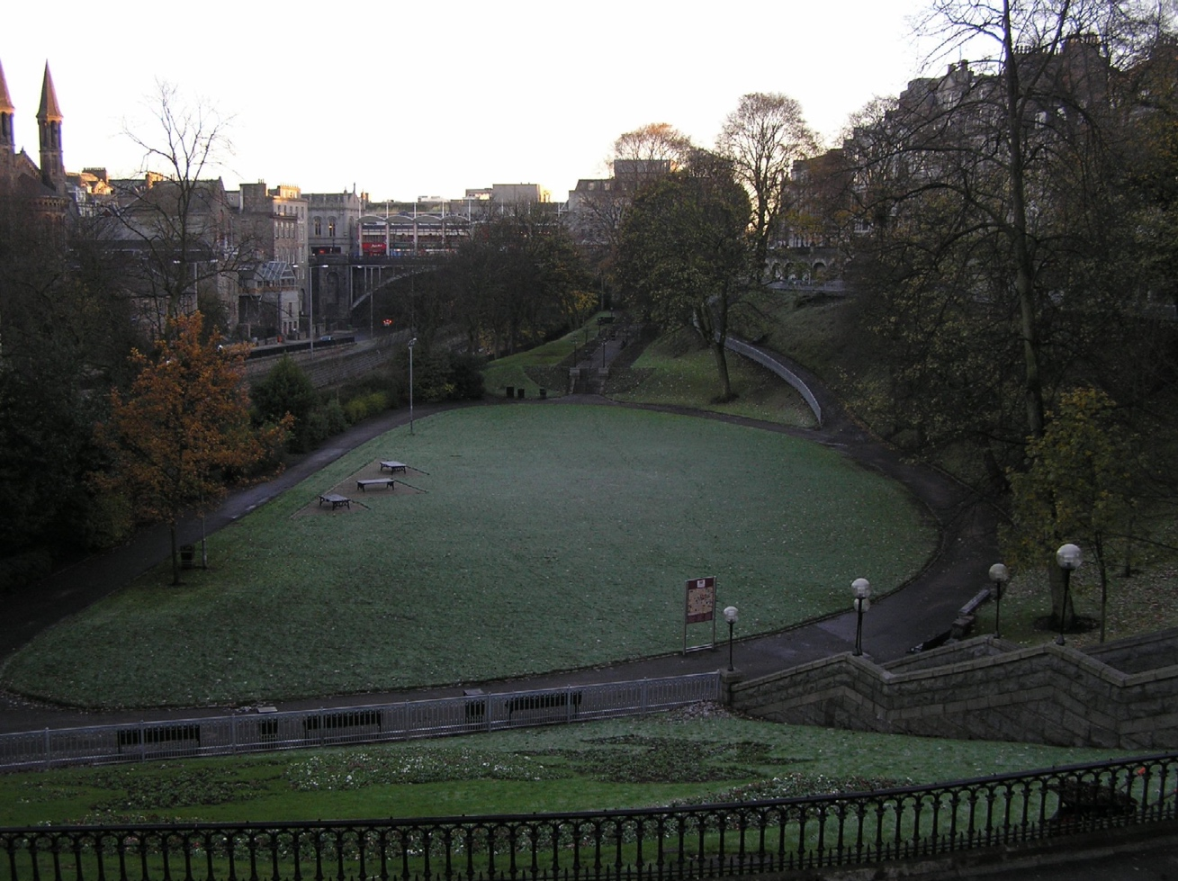

About this photo: Taken in the twilight of a winter afternoon, this photo shows Union Terrace Park in central Aberdeen, Scotland. To the left is the railway that links Scotland’s third largest city with the rural northeast. In the background are the offices and shops of Union Street, the city’s main street and primary retail area. The steps in the right foreground lead up the hillside to the city library and Her Majesty’s Theatre.

Questions for Consideration:
- What estimates can we make about the town from this photo?
- What about its environmental setting?
- Do you see any indications that Aberdeen is the major seaport for North Sea oil?
- Can we make any guesses about what the people of Aberdeen value?

Lesson 2

Teacher Tool 2.2—Space in Landscape

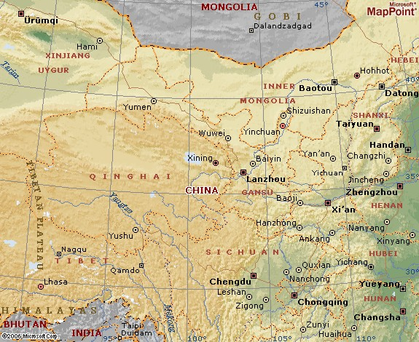

Physical and political map of western China.

Questions for Consideration:
- What information does this map give that is different from the previous photo?
- What estimates can we make of how environment has shaped this part of the world?
- Find Chongqing. Given its position in relation to other towns and to the environment, what estimates can we make about its importance or regional influence?

Lesson 2

Teacher Tool 2.3—Space in Panorama

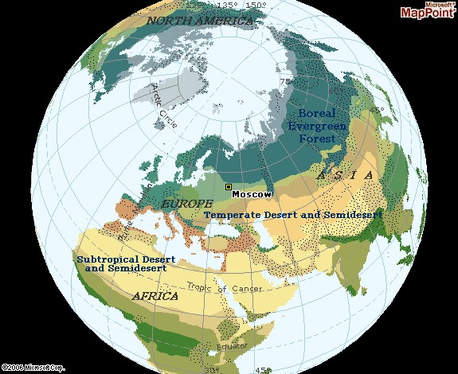

Physical and partial political map of Eurasia, with elements of Africa and Oceania. From this perspective, it is easy to understand the Mediterranean, Red, Black, and Caspian seas as lakes within Afro Eurasia.

Questions for Consideration:
- What features does this map show that the other two do not?
- What does this map tell you about the people living in this region?
- What route(s) could people use to get around?
- How much of an influence would the ocean/seas have on history? Why?

Lesson 3

Maps of Time

Preparation
As with the previous lesson, this one allows for different modes of learning. In addition to copies of the handouts, you will need:

- three 20-foot (6m) lengths of clothesline. You can get away with one, but you will have a better tool for comparison with three.
- large cards (see Teacher Tools 3.1 - 3.3).

Introduction
While history cannot be broken down into a simple series of dates, it is important to be able to appreciate the correlation between time, people, ideas, and the environment. In some cases historians are concerned with a span of weeks, as in the case of the man Menocchio in Carlo Ginzburg’s book, The Cheese and the Worms (Baltimore: Johns Hopkins UP, 1991). In other cases historians consider a span of decades, as in the case of studies of historical trends during the “long nineteenth century” (1789-1914). Or, they may study very long periods of history such as 90,000 years or more when humans populated parts of the world outside of Africa. As with maps of space, each of these spans of time tells us different parts of history’s tale. Which perspective a student adopts depends on the levels of detail that are being investigated.

Activity: Walking through time
1. Before starting this activity, identify a locally well-known city or landmark that is about 1000 miles (1600km) from your school. Distribute the cards from Teacher Tools 3.1.

2. Stretch the clothesline across the classroom. Two volunteers might hold it up (though it would be better to secure it to a wall). One student represents the present, the other represents some time in the past.

3. Remind students of how a scale was used in map-making so that a fraction of an inch was used to represent far greater distances. Ask the students to imagine that each inch (25mm) represents 200 years in time.

4. The modern myth of creation indicates that, using this scale, the “Big Bang” occurred in the city or landmark identified in “I” above. Have the students affix the cards at appropriate intervals on the clothesline.

5. Repeat this process using the cards from Teacher Tools 3.2 and 3.3.

6. Discuss these questions: What did students learn from seeing timelines laid out in this manner? What are the benefits of each scale? The drawbacks?

Lesson 3

Teacher Tool 3.1—Time in Panorama

The cards below are designed to correspond to a time scale of 1-inch (25mm) as equivalent to 200 years. Print the cards on heavy paper, then attach a string or yarn to each card so that it can be tied to the clothesline at the appropriate place.

Language used for communication  about 100,000 years ago |  | Printing with ceramic type  East Asia  about 1,000 years ago
Development of agriculture  Southwest Asia  about 10,000 years ago |  | Protestant Reformation  about 500 years ago
Cities appear  Southwest Asia  about 6,000 years ago |  | The Qing Empire in China  1644
Akkadian Empire  Mesopotamia  about 4,300 years ago |  | Industrial Revolution  about 1750
Roman Empire  about 2,500 years ago |  | World War I  1914-1918
Moche urban society  Andean South America  about 1,700 years ago |  | The Great Recession  2008

Lesson 3
Teacher Tool 3.2—Time in Landscape

The cards below are designed to correspond to a time scale of 1 inch (25mm) as equivalent to one year. Print the cards on heavy paper, then attach a string or yarn so that the card can be tied to the clothesline. Note that this series of cards can be integrated into the larger issue that appear with Teaching Tools 2.1 and facilitate discussion of scale.

Industrial Revolution Starts  about 1750 |  | Assassination of Archduke Ferdinand  1914
World war between Britain and France ended  1763 |  | Great Depression starts  1929
Steam train invented  George Stephenson  1814 |  | Cold War begins  1946
Suez Canal opens  Egypt  1869 |  | Rachel Carson publishes Silent Spring  1962
Ethiopia defeats Italy at the battle of Adwa |  | Apartheid ends in South Africa  1991
Human Air Travel  The Wright Brothers  1903 |  | The Arab Spring  2011

Lesson 3

Teacher Tool 3.3—Time in Close-up
The cards below are designed to correspond to a time scale of 10 inches (254 mm) being equivalent to one hour; the 20-foot clothesline essentially represents a single day. The following cards are based on the diary of a Scottish immigrant during his transatlantic voyage in 1853. Alternatively, you may make blank cards for students to describe their own day

Awoke to hear little Katie crying  6:30 am |  | Dinner in the cabin  (Fish with fried potatoes)  1:00 pm
Breakfast with the Captain  (oatmeal with cream & salt, coffee)  9:00 am |  | Talked to Mr. MacDonald  3:00 pm
Walked on deck  Still becalmed  10:30 am |  | Tea in the cabin  (Tea with stale toast)  4:00 pm
Dr Johnstone in to see Katie  Passengers in steerage are also ill  12:00 pm |  | Supper with friends  (Dried beef, potatoes, claret)  8:00 pm

Lesson 4

Maps of History

Preparation
This lesson offers primarily a review of the previous two and introduces the concepts of using maps of time and space together to see historical developments. Photocopies of Student Handout 4.1 will be needed, if it is used. Having visual aids from the previous lessons and/or the Student Handouts for reference may be useful.

Introduction
The Oxford English Dictionary describes “history” as “a relation of incidents.” In this lesson, we will examine the relationship between time and space, again relying on a flexible use of scale and how these help us to understand the people, environment, and information around us. This lesson points out how the scale of time being applied is independent of the scale of space.

Activities
I. Review of maps of space
  - Review the elements of a map.
  - Discuss benefits of each view of space, and contrast each to the others.

II. Review of maps of time
- Review the elements of a map.
- Discuss benefits of each view of space, and contrast each to the others.

III. The Relationship of the two
- Student Handout 4.1 is aimed at helping students see connections of time and space.
- Is it necessary to use the same perspective in time as in space? For example, if one uses a close-up view of space, must one use a close-up view of time?
- What are some of the circumstances where we would want to use the same perspective for both space and time? When would we want to use different perspectives?
- Is there a value decision associated with the perspectives?

IV. How does this relate to “history?”
- Why is the ability to shift scale important?
- Why not use just one scale?

Assessment
Since this lesson is primarily a review and analysis of the previous lessons, it is presumed that sufficient assessment has been completed at this point. Formalized testing may be desired.

Lesson 4

Student Handout 4.1
Below are listed collections of documents that are available for study. Read through the descriptions and decide whether the collection will give you a relatively large-scale (panorama), medium-scale (landscape), or narrow scale (closeup) understanding of time and space.

Document Collection One:
Archive Record 1: Diary of A.G. MacKellar, January 1844 - June 1845, outlining his travel from Inverness, Scotland, to Louisville, Kentucky (USA).

Archive Record 2: Letter of Witold Brejnak, 12 March 1898, to his parents in Krakow, Poland, describing life in Spain.

Archive Record 3: Employment records of the Union-Pacific Railway, recording the names, nationality, age, and length of employment for those working on the Transcontinental Railway (1863).

Archive Record 4: Ship manifest, 5 August 1804, names and personal data on persons that sailed from Nice, France, and eventually landed at Buenos Aires, Argentina.

What perspective does this collection provide in time?

What perspective does this collection provide in space?

Document Collection Two:
Archive Record 1: Statement of account, January 1954 - December 1954, detailing farm expenses (groceries, heating, stock feed, etc.)

Archive Record 2: Trust Deed, recorded July 1953 detailing exact farm property boundaries.

Archive Record 3: Letter from an unknown farm laborer to his mother dated 11 November 1954 describing other laborers and daily routines on the farm.

What perspective does this collection provide in time?

What perspective does this collection provide in space?

Document Collection Three:
Archive Record 1: Biologists’ field records, study completed in 2006 describing the number and variety of plants and animals along the Negro River (a tributary of the Amazon) in Columbia.

Archive Record 2: Audiotape interviews with native elders describing life and the setting of their village along the Negro River. The stories relate to approximately 1910.

Archive Record 3: Biologist’s report on findings related to a tree that fell during a violent storm along the Negro River. Study of the tree’s rings demonstrates growth spurts, fires, and drought, and it indicates that the tree was approximately 400 years old.

Archive Record 4: Archeologists’ reports and findings of a settlement on the Negro River. Artifacts, fire pits, waste dumps, and so on suggest the environmental setting dating back approximately 1,500 years.

What perspective does this collection provide in time?

What perspective does this collection provide in space?

This unit and the Three Essential Questions

If one examines climatic changes in a region, which perspective will be most useful—large-scale (panorama), medium-scale (landscape), or narrow scale (closeup). Which perspective would be least useful? How might a map of space help us to understand our environment?
What might a map of time from the large-scale, panorama perspective teach us about human interaction? What about the closeup perspective? Does a map of space tell us anything about how humans communicate with each other or share information?
Is it possible to tell anything about ideas from maps of time and space? What clues might show us the use of ideas?

This unit and the Standards in Historical Thinking
Historical Thinking Standard 1: Chronological Thinking
The student is able to (B) identify the temporal structure of a historical narrative or story.

Historical Thinking Standard 2: Historical Comprehension
The student is able to (G) draw upon data in historical maps.

Historical Thinking Standard 3: Historical Analysis and Interpretation
The student is able to (D) draw comparisons across eras and regions in order to define enduring issues as well as large-scale or long-term developments that transcend regional and temporal boundaries.

Historical Thinking Standard 4: Historical Research Capabilities
The student is able to (B) obtain historical data from a variety of sources.

Resources for Teachers and Students
Christian, David. Maps of Time: An Introduction to Big History. Berkeley: University of California Press, 2004. An example of historical work on a very grand scale.

Christian, David. This Fleeting World: A Very Small Book of Big History, or The Story of the Universe and History of Humanity. Great Barrington, MA: Berkshire Publishing, 2018.

Crosby, Alfred W. Ecological Imperialism: The Biological Expansion of Europe, 900-1900. Cambridge: Cambridge UP, 1986. This work provides a fine example of smooth transitions between large and small scales.

Dunn, Ross E., Laura J. Mitchell, and Kerry Ward, eds. The New World History: A Field Guide for Teachers and Students. Berkeley, CA: University of California Press, 2016. Several essays in this edited collection on conceptualizing and teaching world history address problems of historical scale.

Ginzburg, Carlo. The Cheese and the Worms: The Cosmos of a Sixteenth-Century Miller. London: Routledge & Kegan Paul, 1980. An example of historical work on a highly focused scale, often referred to as “microhistory.”

Lewis, Martin W. and Kären E. Wigen. The Myth of Continents: A Critique of Metageography. Berkeley, CA: University of California Press, 1997. Geographer Wigen, and historian Lewis investigate the world’s basic geographical divisions that we take for granted. They trace the history of several misconceptions on the global scale and in relation to specific land masses. They challenge, for example, the traditional division of the world into seven continents.

Mackillop, Andrew. “More Fruitful than the Soil:” Army, Empire, and the Scottish Highlands, 1715-1815. (East Linton: Tuckwell Press, 2000). An example of a landscape view of time, with a closeup view of geographical space.

McNeill, JR and William H. McNeill. The Human Web: A Bird’s-Eye View of World History. New York: Norton, 2003. A panoramic view of the human past from the dawn of tool-making to the present.

Northrop, Douglas, ed. A Companion to World History. Malden, MA: Wiley Blackwell, 2012. This volume of thirty-three essays includes several that addresses issues of scale in time and space.

Wills, John E, Jr. 1688: A Global History. New York: Norton, 2001. A book that embraces the entire world but focuses on just one year.

